**Experiment No. - 11**

**Name-** Bhavesh Kewalramani

**Roll No.-** A-25

**Section-**  A

**Semester-** 6th

**Shift-** 1st

**Aim:**

To demonstrate product tracking and agile project management using JIRA.

**Theory:**

Jira is a suite of agile work management solutions that powers collaboration across all teams from concept to customer, empowering you to do the best work of your life, together. Jira offers several products and deployment options that are purpose-built for Software, IT, Business, Ops teams, and more. Read on to see which is right for you.

## About the Jira family

Jira helps teams plan, assign, track, report, and manage work and brings teams together for everything from agile software development and customer support to start-ups and enterprises.

Software teams build better with Jira Software, the #1 tool for agile teams. Deliver amazing service experiences across all teams from IT, Dev, Ops, and more with Jira Service Management. Business teams can unlock the power of agile and collaborate better with Jira Work Management. Jira Align is an enterprise agile planning platform that connects work at scale.

With templates and solutions crafted for every team and Jira as your common language - work moves fluently and transparently across your organization.

### **Jira products overview**

Built for every member of your agile team and beyond to plan, track, and ship world-class software.

[Learn More](https://www.atlassian.com/software/jira)

Give your customers an easy way to ask for help and your agents a faster way to deliver it.

[Learn More](https://www.atlassian.com/software/jira/service-management)

Manage any business project including marketing campaigns, HR onboarding, approvals and legal document reviews.

[Learn More](https://www.atlassian.com/software/jira/work-management)

Enterprise Agile Planning platform that connects product, program, and portfolio strategy to technical execution, at scale.

[Learn More](https://www.atlassian.com/software/jira/align)

#### **Users**

* [Software developers](https://www.atlassian.com/software/jira/guides/use-cases/who-uses-jira#how-software-development-teams-use-jira)
* QA and testing
* Project managers
* Program managers
* Product designer
* Product owners
* Scrum masters

#### **Use cases**

* [Agile teams](https://www.atlassian.com/software/jira/guides/use-cases/what-is-jira-used-for#jira-for-agile-teams)
* [Bug tracking](https://www.atlassian.com/software/jira/guides/use-cases/what-is-jira-used-for#jira-for-bug-tracking-features)
* [Project management](https://www.atlassian.com/software/jira/guides/use-cases/what-is-jira-used-for#jira-for-project-management-teams)
* [Product management](https://www.atlassian.com/software/jira/guides/use-cases/what-is-jira-used-for#jira-for-product-management-teams)
* Process management
* [Task management](https://www.atlassian.com/software/jira/guides/use-cases/what-is-jira-used-for#jira-for-task-management)
* [Software development](https://www.atlassian.com/software/jira/guides/use-cases/what-is-jira-used-for#jira-for-software-development-teams)
* [Requirements & test case management](https://www.atlassian.com/software/jira/guides/use-cases/what-is-jira-used-for#Jira-for-requirements-&-test-case-management)

#### **Hosting**

* Cloud, Data Center

#### **Licensing**

* Licensed by user
* All Jira Software users can access Jira Work Management features
* Users have access to
  + Software projects & features
  + Business projects & features

[Learn more about Jira Software pricing](https://www.atlassian.com/software/jira/pricing)

#### **Important integrations for Jira Software**

[Confluence](https://www.atlassian.com/software/jira/integrations), [Bitbucket](https://www.atlassian.com/software/jira/integrations), [Trello](https://www.atlassian.com/software/jira/integrations), [Slack](https://www.atlassian.com/software/jira/guides/expand-jira/jira-slack-integration), GitHub, Microsoft, Google  
[Learn more](https://www.atlassian.com/software/jira/integrations)

#### **Users**

* DevOps managers
* IT operations managers
* Support managers
* IT Service desk agents
* Enterprise architect
* Services owner

#### **Use cases**

* ITSM
* Service Desk
* Enterprise Service Management
* Service Request Management
* Incident Management
* Problem Management
* Change Management
* Asset Management
* Customer Support
* Ticketing Support

#### **Hosting**

* Cloud, Data Center

#### **Licensing**

* Licensed by agent
* Free and unlimited customers (users submitting requests)
* All Jira Service Management agents can access Jira Work Management features
* Users have access to
  + Service management projects & features
  + Software projects & features
  + Business projects & features

#### **Users**

* Business users
* Marketing
* Operations
* HR
* Legal
* Finance
* IT

#### **Use cases**

* Non-technical team projects
* Workflow approvals
* Task management

#### **Hosting**

* Cloud

#### **Licensing**

* All Jira Software users can access Jira Work Management features.
* Users have access to Business Projects & features (Dashboards, Reports, etc).

#### **Important integrations for Jira Work Management**

Confluence

#### **Users**

* [Portfolio managers](https://www.atlassian.com/software/jira/align/portfolio)
* [Executives](https://www.atlassian.com/software/jira/align/executives)
* [Program managers](https://www.atlassian.com/software/jira/align/program-manager)
* [Release train engineers](https://www.atlassian.com/software/jira/align/rte)[Product managers](https://www.atlassian.com/software/jira/align/product-manager)
* [Product delivery teams](https://www.atlassian.com/software/jira/align/product-delivery)
* [Transformation teams](https://www.atlassian.com/software/jira/align/transformation)
* [Finance](https://www.atlassian.com/software/jira/align/finance)

#### **Use cases**

* Enterprise agile transformation
* Scaling agile
* [Spotify](https://www.atlassian.com/software/jira/align/spotify)
* [SAFe](https://www.atlassian.com/software/jira/align/safe)
* [Scrum@Scale](https://www.atlassian.com/software/jira/align/scrum-at-scale)
* [LeSS](https://www.atlassian.com/software/jira/align/less)
* [Disciplined agile](https://www.atlassian.com/software/jira/align/da)
* [Hybrid](https://www.atlassian.com/software/jira/align/hybrid)

#### **Hosting**

* Cloud, Dedicated Cloud

#### **Licensing**

* A Jira Align Standard user has access to all functionality for collaborative planning, management execution and analysis/reporting/visualization across Program and/or Team modules.
* A Jira Align Enterprise user has access to all functionality of a Standard user plus access to Enterprise, Portfolio, and Solution modules.

#### **Important integrations for Jira Align**

[Jira Software (Premium)](https://www.atlassian.com/software/jira/premium), Trello, Azure DevOps, Tasktop

## Jira Software hosting options

Jira Software is available in two hosting options: cloud and self-managed. Not sure which option is right for you? Check out this overview:



### Cloud

With **Jira Software Cloud**, we host and set up your Jira Software site in the cloud for you. This is generally the best option for teams who want to get started quickly and easily, and for teams who don't want to manage the technical complexity of hosting themselves. [Learn more](https://www.atlassian.com/software/jira/pricing)



### Data Center

With **Jira Software Data Center**, you can host Jira Software on your own hardware or with IaaS vendors like AWS and Azure. This is generally the best option for enterprise teams who need uninterrupted access to Jira Software and performance at scale. [Learn more](https://www.atlassian.com/enterprise/data-center)

## Key terms to know

### **Issues**

A Jira 'issue' refers to a single work item of any type or size that is tracked from creation to completion. For example, an issue could be a feature being developed by a software team, a to-do item for a marketing team, or a contract that needs to be written by a legal team.

Tip: Other commonly used terms for issues are 'requests', 'tickets' or 'tasks'. We recommend using 'issues' to help your team stay on the same page when working across the Jira product family.

### **Projects**

A project is, quite simply, a collection of issues that are held in common by purpose or context. Issues grouped into projects can be configured in a variety of ways, ranging from visibility restrictions to available workflows.

Jira Software projects are flexible working spaces that allow you to group like issues by team, business unit, product, or stream of work. Projects don't need to be tied to the same delivery date. For example, if you group your issues by team, you could have a marketing project, a development project, and a legal project, all of which would track ongoing work of those particular teams. Every issue would be represented by an issue keys (specific to a project) and an issue number, i.e. MKT-13, DEV-4, LEG-1.

### **Boards**

A board in Jira software is a part of a project that displays issues giving teams a flexible way to view, manage, and reporting on work in progress. Simply put, a board is a visual representation of a team’s workflow within a project.

### **Workflows**

Workflows represent the sequential path an issue takes from creation to completion. A basic workflow might look something like this:

In this case, Open, Done, and the labels in between represent the status an issue can take, while the arrows represent potential transitions from one status to another. Workflows can be simple or complex, with conditions, triggers, validators, and post functions. We'll dive deeper into these advanced configurations later in this guide. For now, it is recommended for novice Jira Software admins to keep their workflows as simple as possible, until business needs to determine the requirements for complex workflow configurations.

### **Agile**

Agile is not a Jira Software-specific term. It's a work philosophy that originated in the software development field and has since expanded to a variety of other industries. While we won't belabor the definition here (there are great agile resources for that!), agile emphasizes an iterative approach to work informed by customer feedback where delivery occurs incrementally and continuously. The ideal agile team can move quickly and adapt to changing requirements without missing much of a beat.

So why are we bringing up agile here? Because Jira Software has major feature sets designed particularly for agile, including scrum or kanban. So, when you see terms like boards, estimation, or cards, it's time to start thinking about how agile fits into your work practice.

It's important to note that because agile is a philosophy and a culture of work, simply using Jira Software won't make your team truly agile. That said, it is a tool built to help your team get there.

Jira software helps agile teams do what they do even better. Head over to agile best practices for Jira to learn more. [Go to the guide](https://www.atlassian.com/software/jira/guides/getting-started/best-practices#agile-best-practices-for-jira)

**Output:**

**Product Owner – A-25** Bhavesh Kewalramani

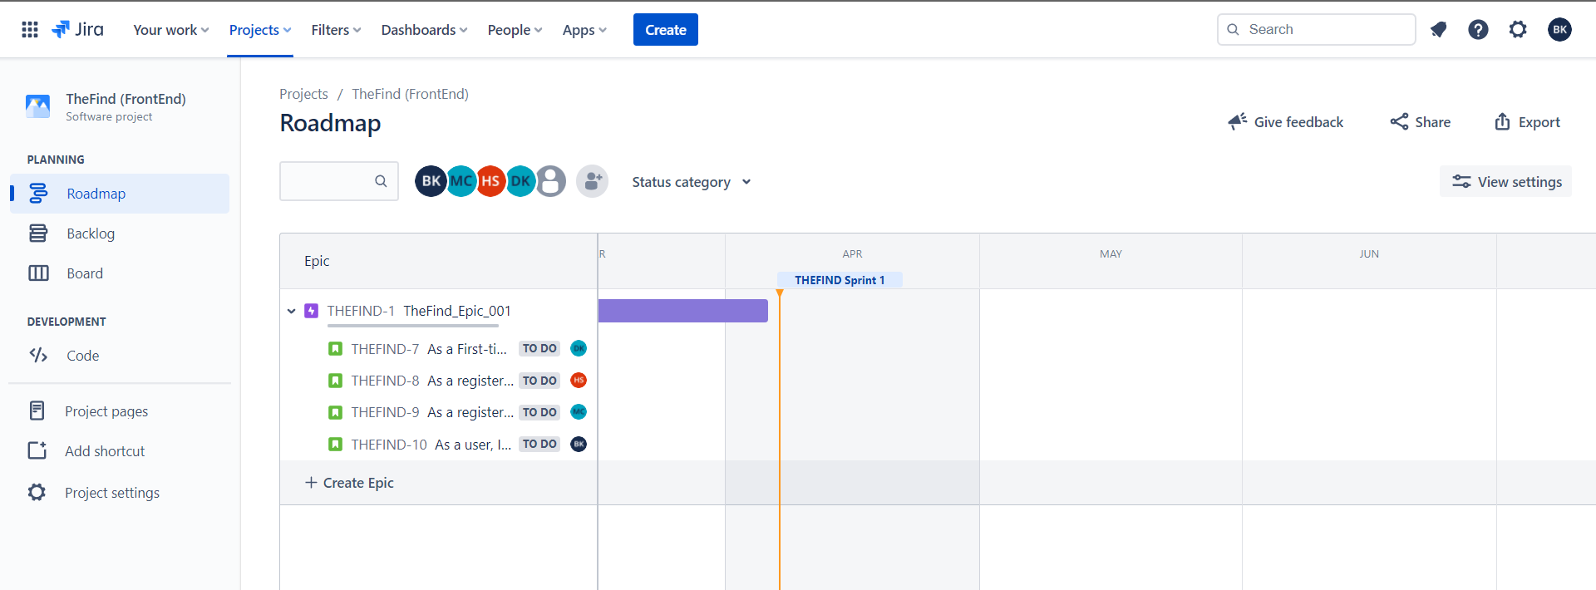

**Developer – A-43** Mohit Chandak

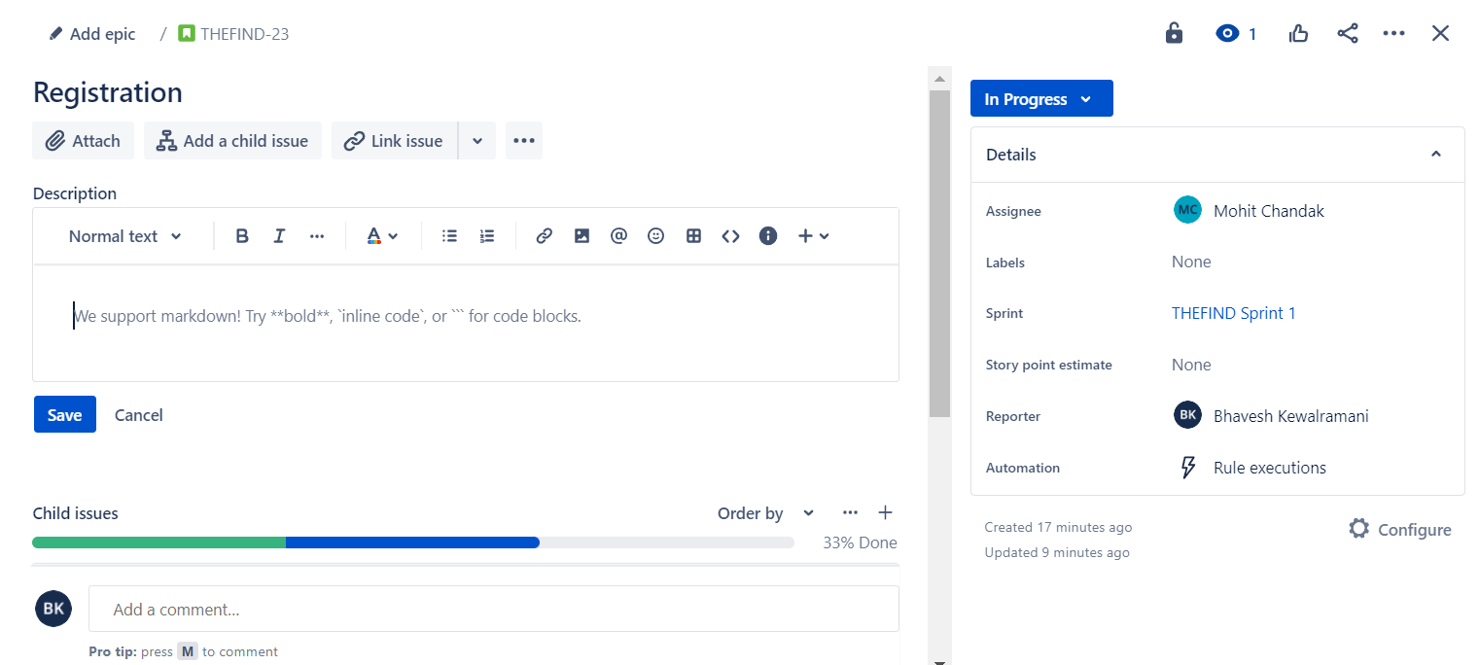

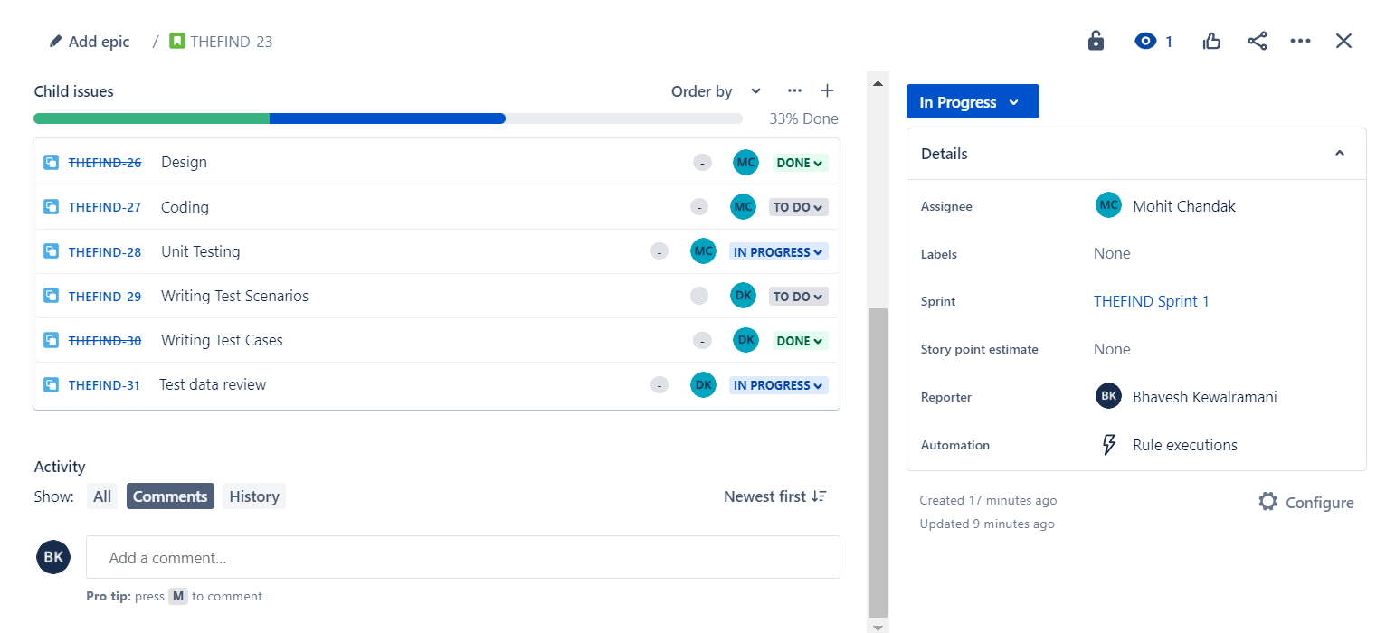

**Tester – A-21** Daksh Kothari

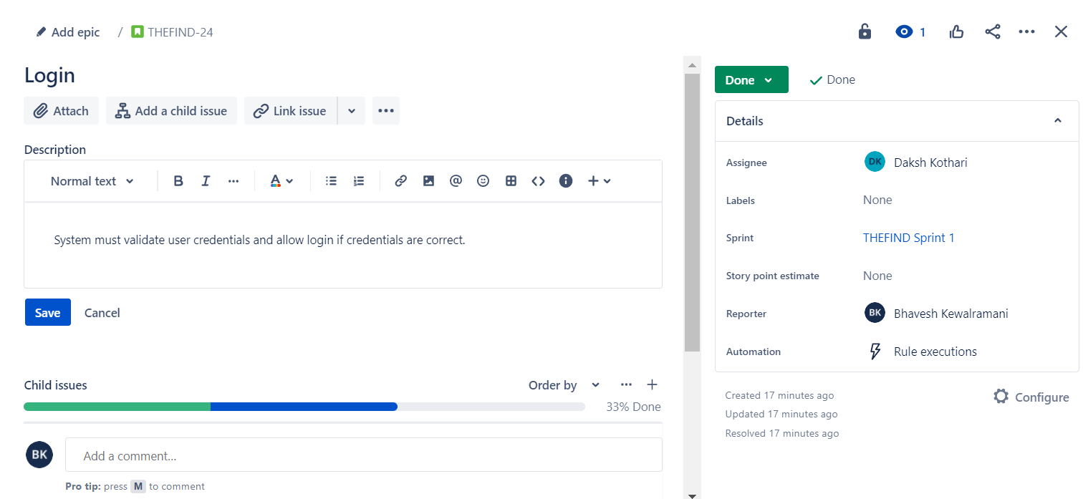

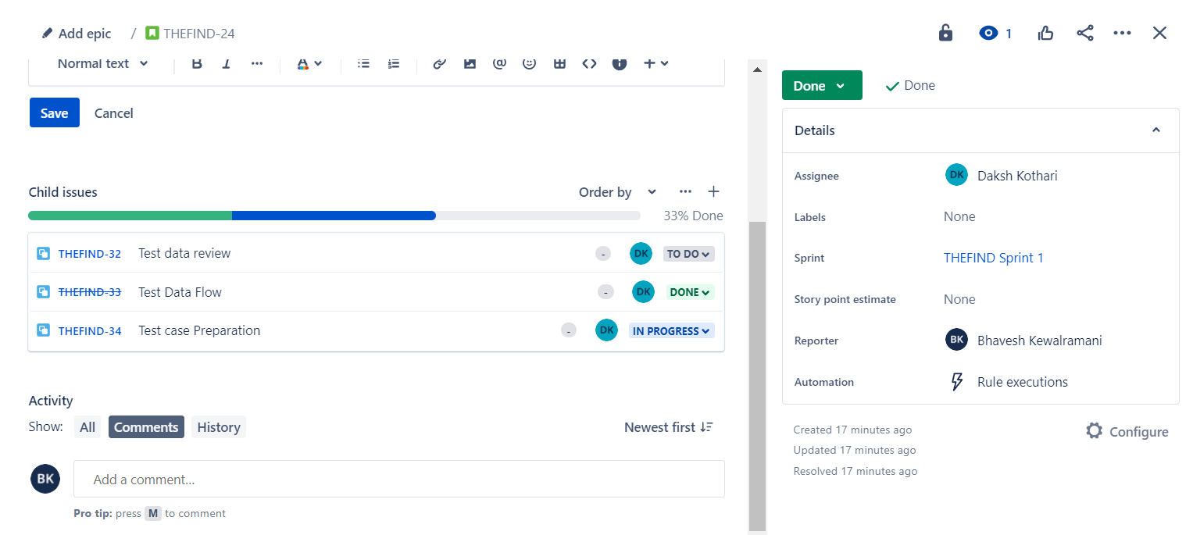

**Scrum Tester – A-22** Harsh Shrirame

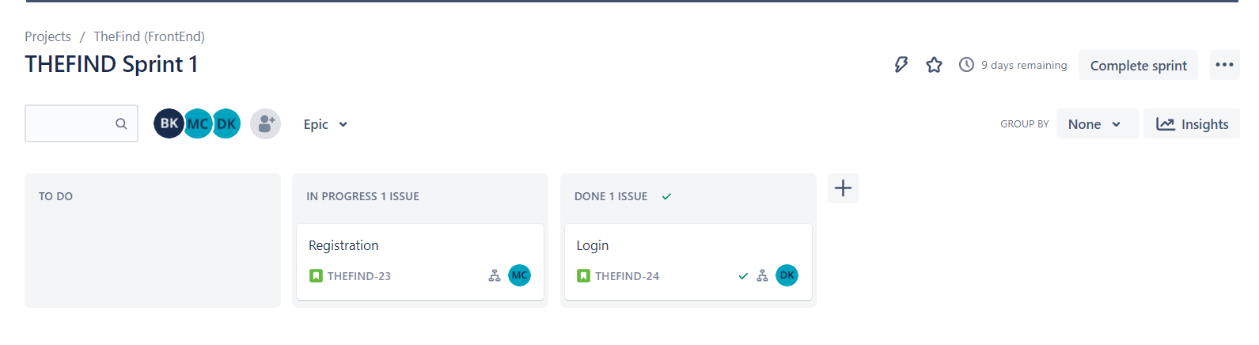

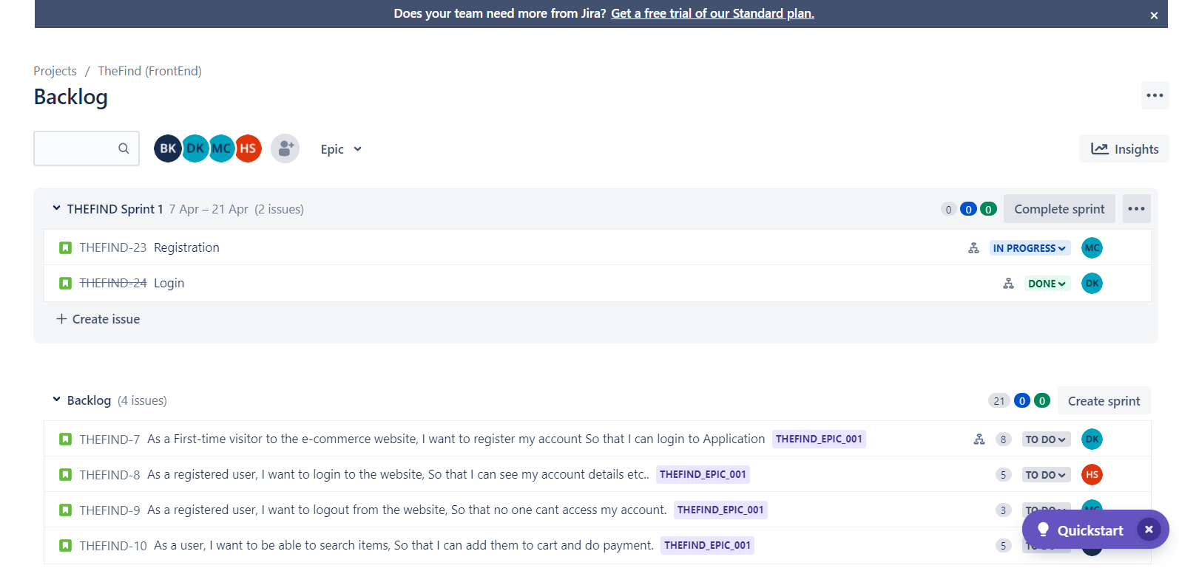

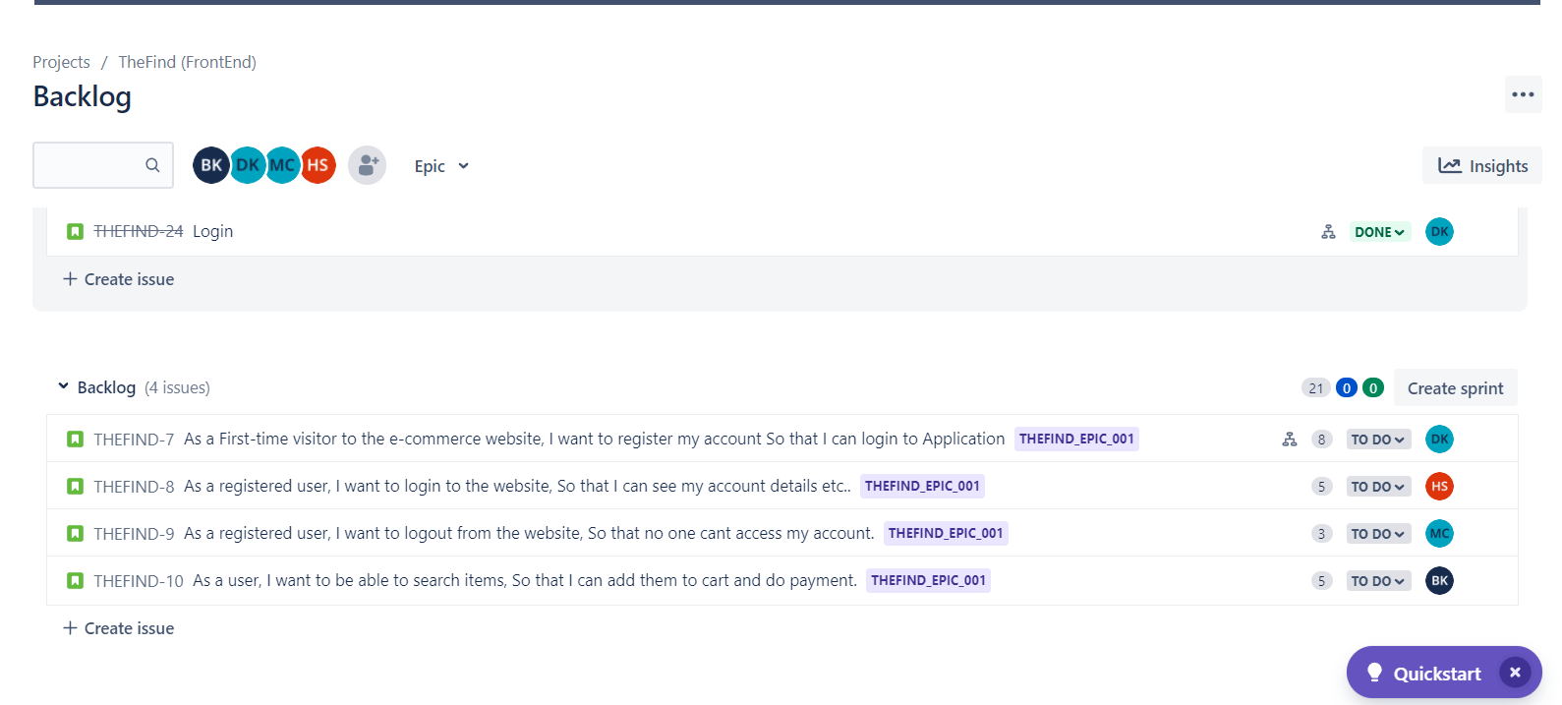

**Conclusion:**

Jira Dashboards have existed since the very earliest days of Jira. They are a hugely powerful tool to allow users at all levels of an organization to view data quickly, simply, and reliably.

It’s very easy to create lots of issues and quickly fill Jira with valuable information, but being able to actually use that information to make decisions is paramount. Jira Dashboards allow the democratization of data by empowering users at all levels of a company to visualize their progress.

There’s no one-size-fits-all solution with dashboards; they are a versatile tool for a huge variety of use cases, only a small handful of which have been covered here.

The most important point to emphasize is that you should have a good understanding of what you are trying to achieve before you start. Dashboards are an organic and dynamic reporting feature that should be constantly reviewed, adapted, and updated.